Circuit design

The diagram below shows the circuit design of the robotic arm controller. It includes the Arduino UNO microprocessor, which connects to the computer. The UNO board is responsible for receiving movement commands from the computer and sending power to the right servo motors to move the appropriate fingers.

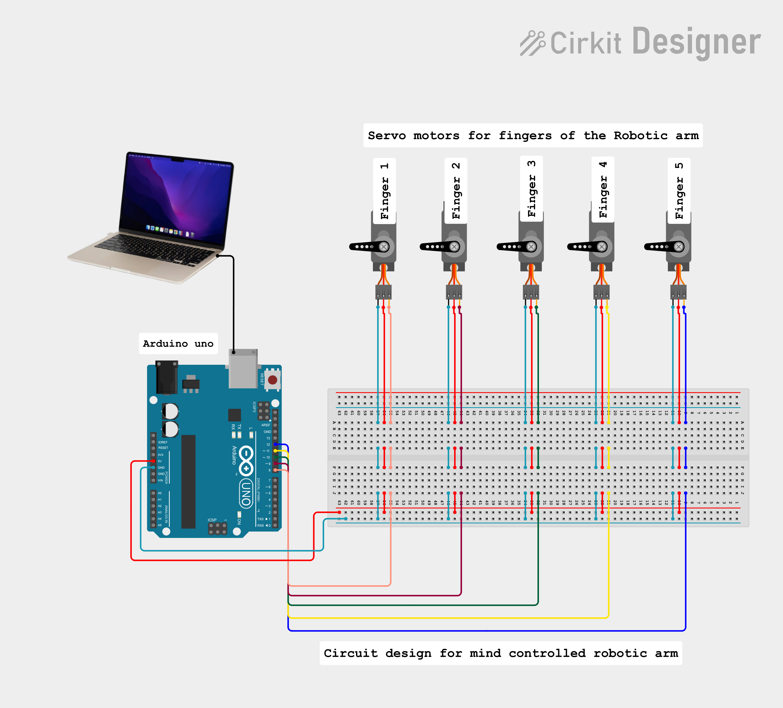

Final construction

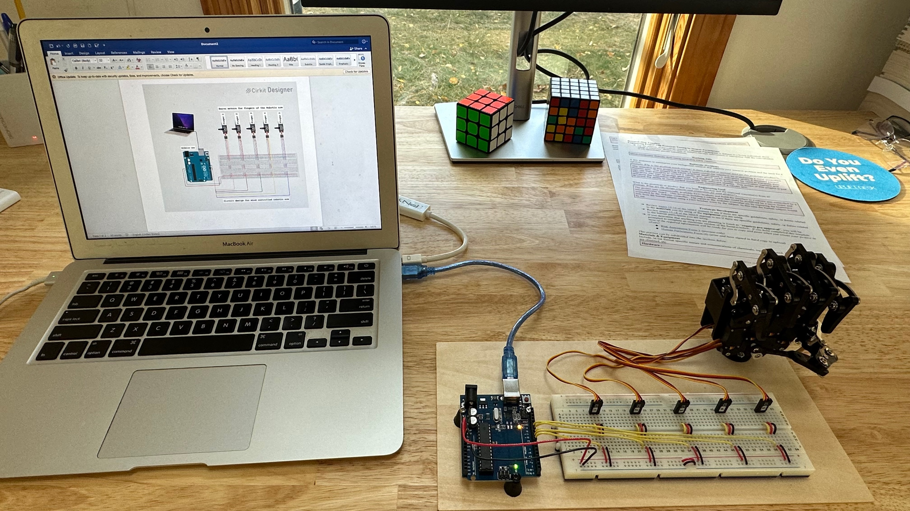

Code repository

<https://github.com/rithvikpkx/MindControlRoboticArm>